**There are several types of AI and I have categorized them as follows:**

1. **Text to text AI**
2. **Text to Image AI**
3. **Sound to Text AI**

**Text to Text AI**

Text-to-Text AI models are a type of natural language processing (NLP) technology that can handle various text-based tasks by converting input text into corresponding output text. These models have shown remarkable versatility in understanding and generating text. Here are some examples of text-to-text AI applications:

1. **Language Translation**: Text-to-Text AI models like Google's T5 (Text-to-Text Transfer Transformer) can translate text from one language to another. For instance, they can convert English text into Hindi or any other language.

Example ( Google Translate)

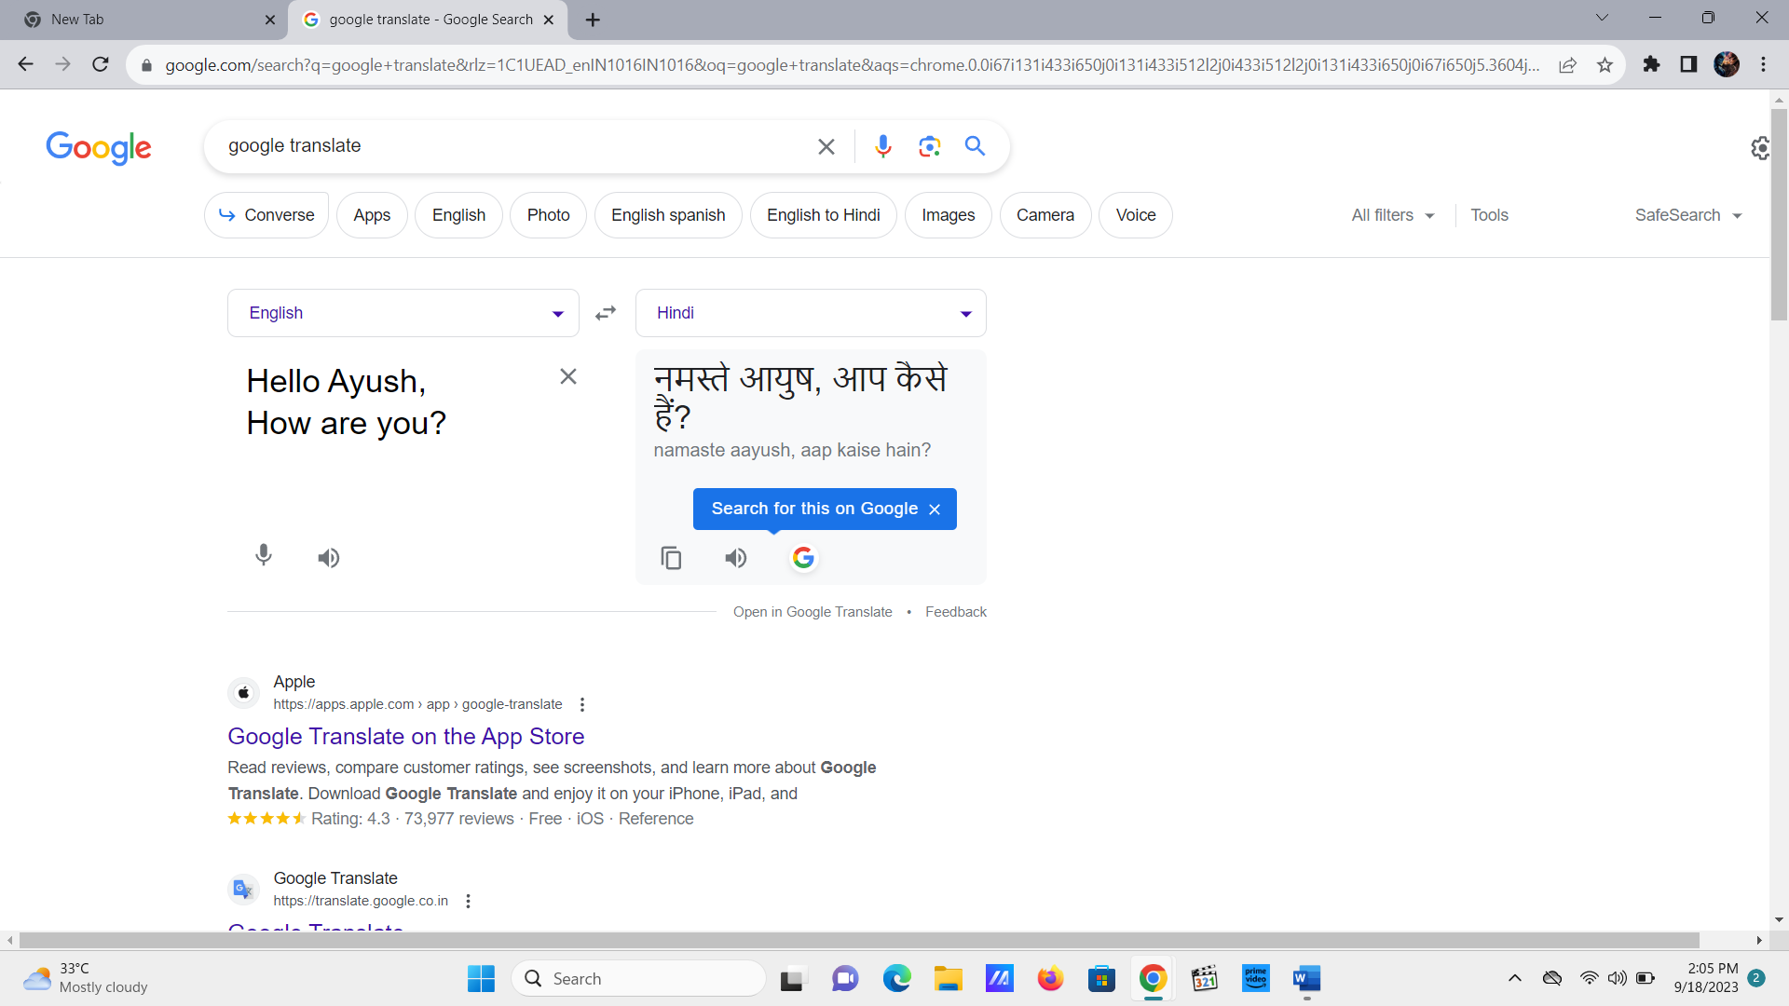

2. **Summarization**: These models can generate concise summaries of longer texts. For example, they can take a news article and produce a shorter, coherent summary that captures the main points.

Example (Quillbot)

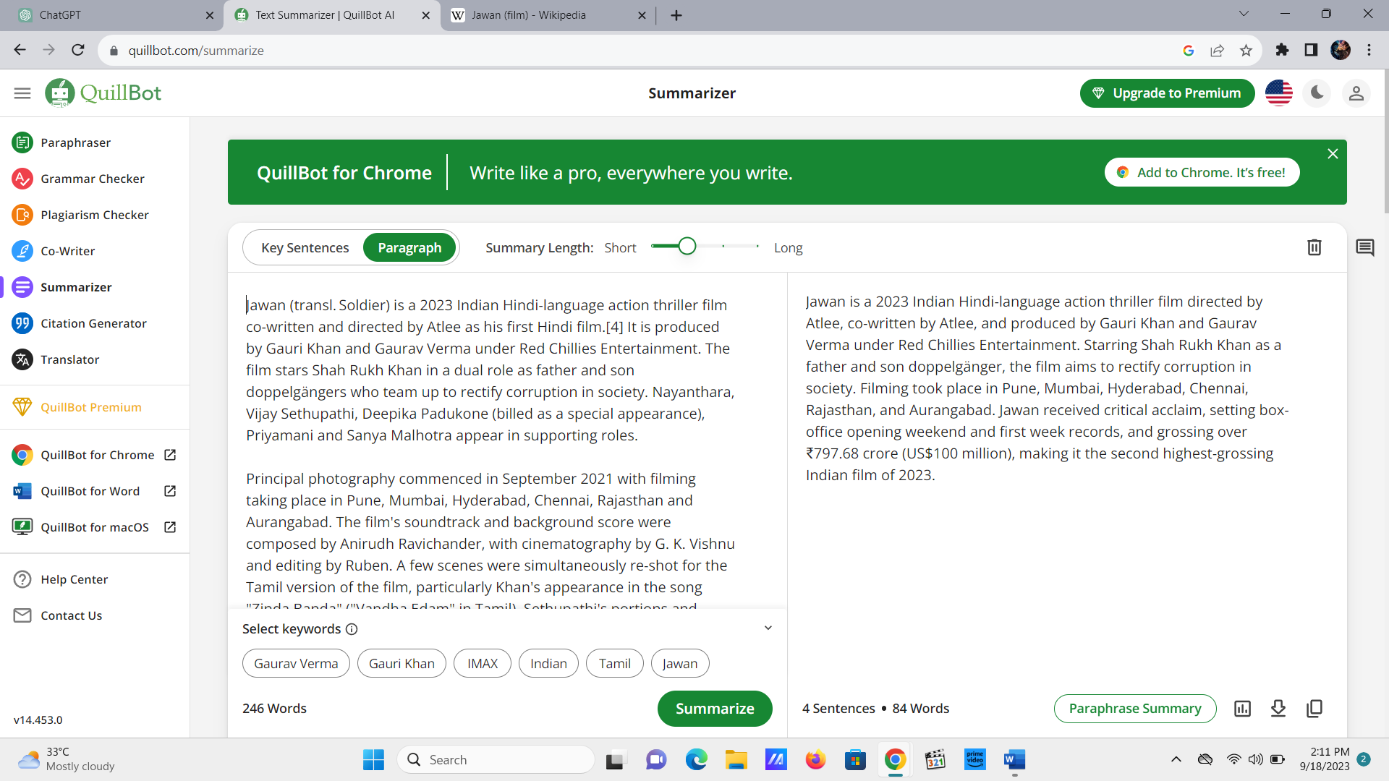

**3. Question Answering**: Text-to-Text models can answer questions based on a given text passage. For instance, you can ask a question and the tool will provide answers to your questions.

Example (CHAT GPT)  
  
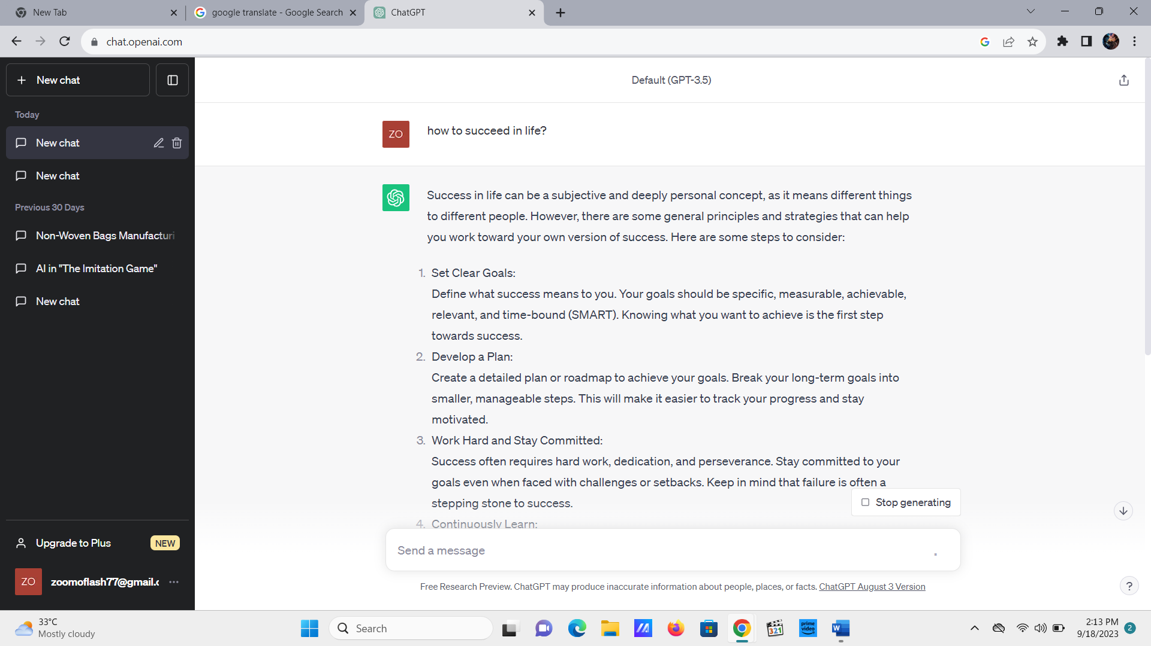

1. **Grammar Correction** – Several tools are there which will help you in maintaining your grammar and to form better sentences, thus improving the overall quality of your sentence.   
     
   Example – Ginger

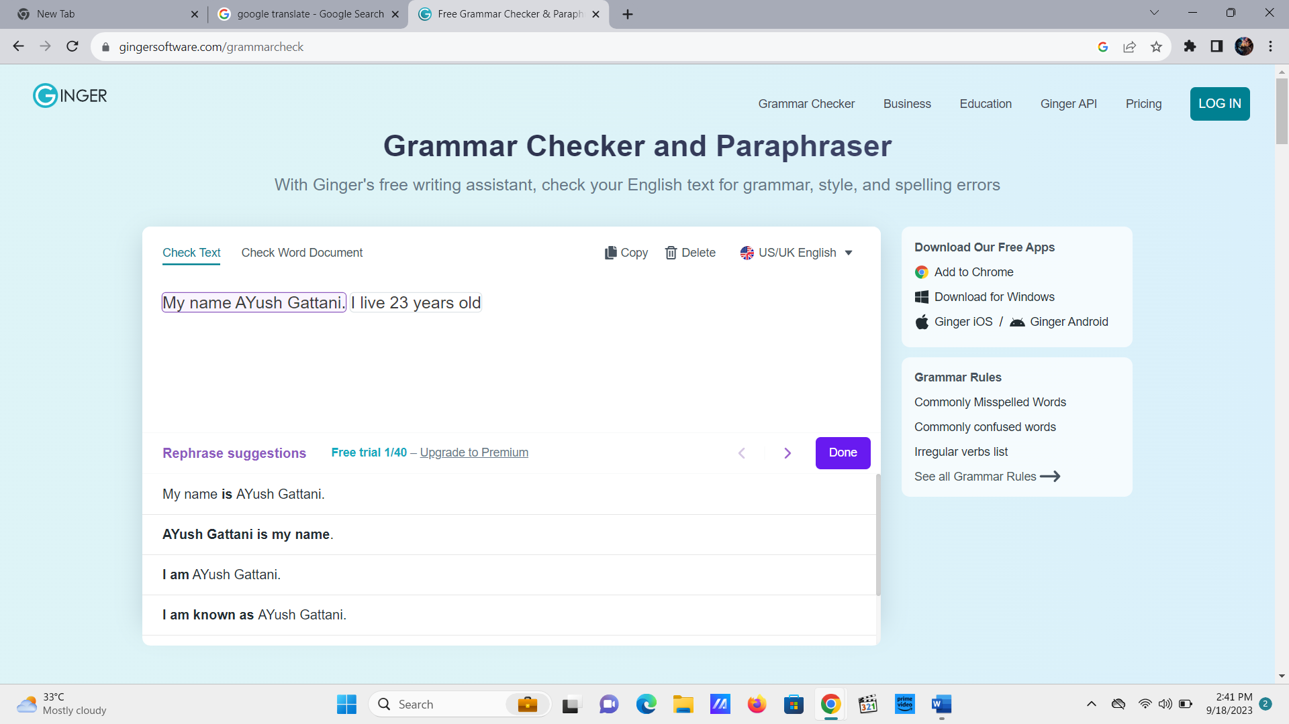

1. **Text to Image AI**

Like the name suggests Text to Image AI deals with the conversion of the given text to a suitable picture of your desire. Several of the AI tools are there which deals with different types of image generation based on our demand and requirement.

While text-to-image AI has made significant advancements, generating highly detailed and realistic images from text can still be challenging, and the results may not always meet human expectations. But nonetheless, the new technology has helped us in many ways and are being put to use by us in daily lives.

**1.Image Generation**: Text-to-Image models can create images from textual descriptions. For example, you can provide a description like "a red apple on a wooden table," and the AI tool will generate an image that matches the description.

Example (CANVA)

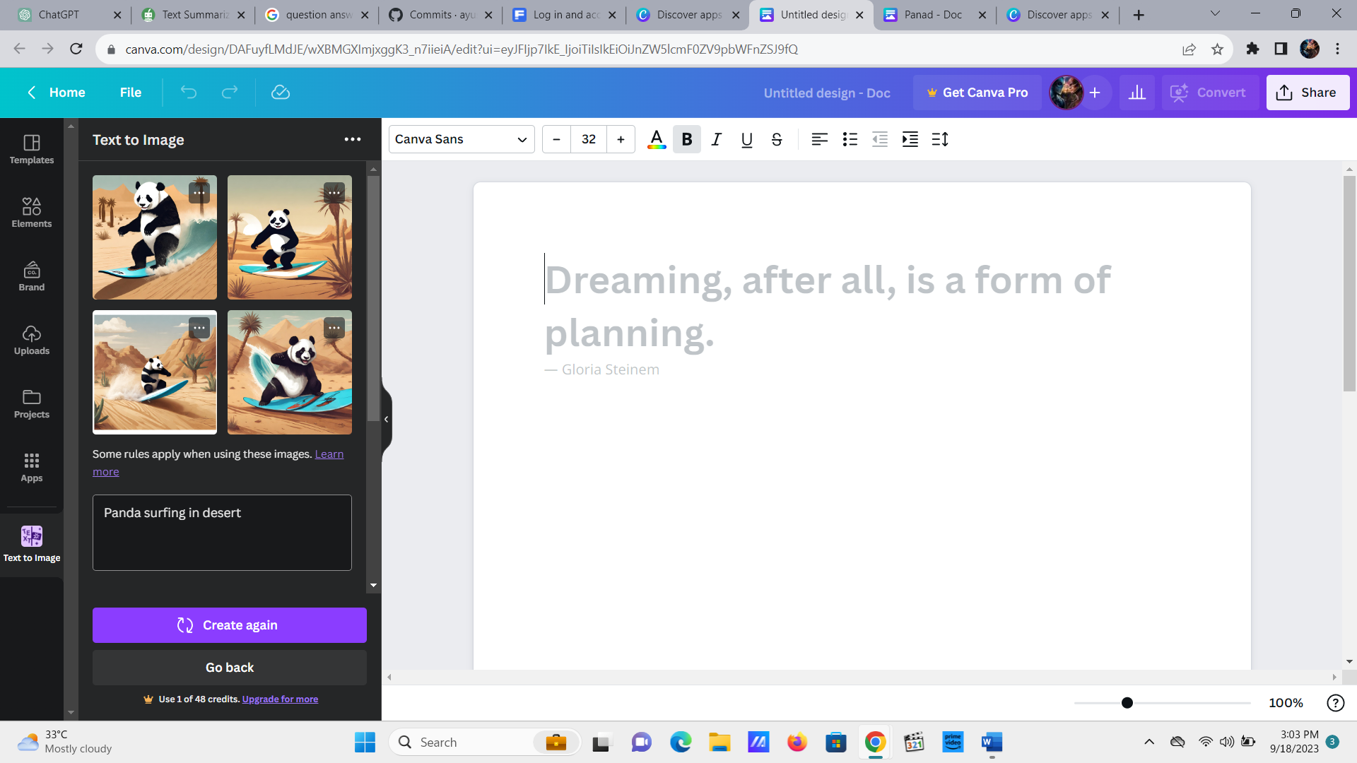

**2. Scene Generation**: These models can be used in video game development and virtual world creation to automatically generate scenes, landscapes, or environments based on textual input.  
Example (FOTOR)  
  
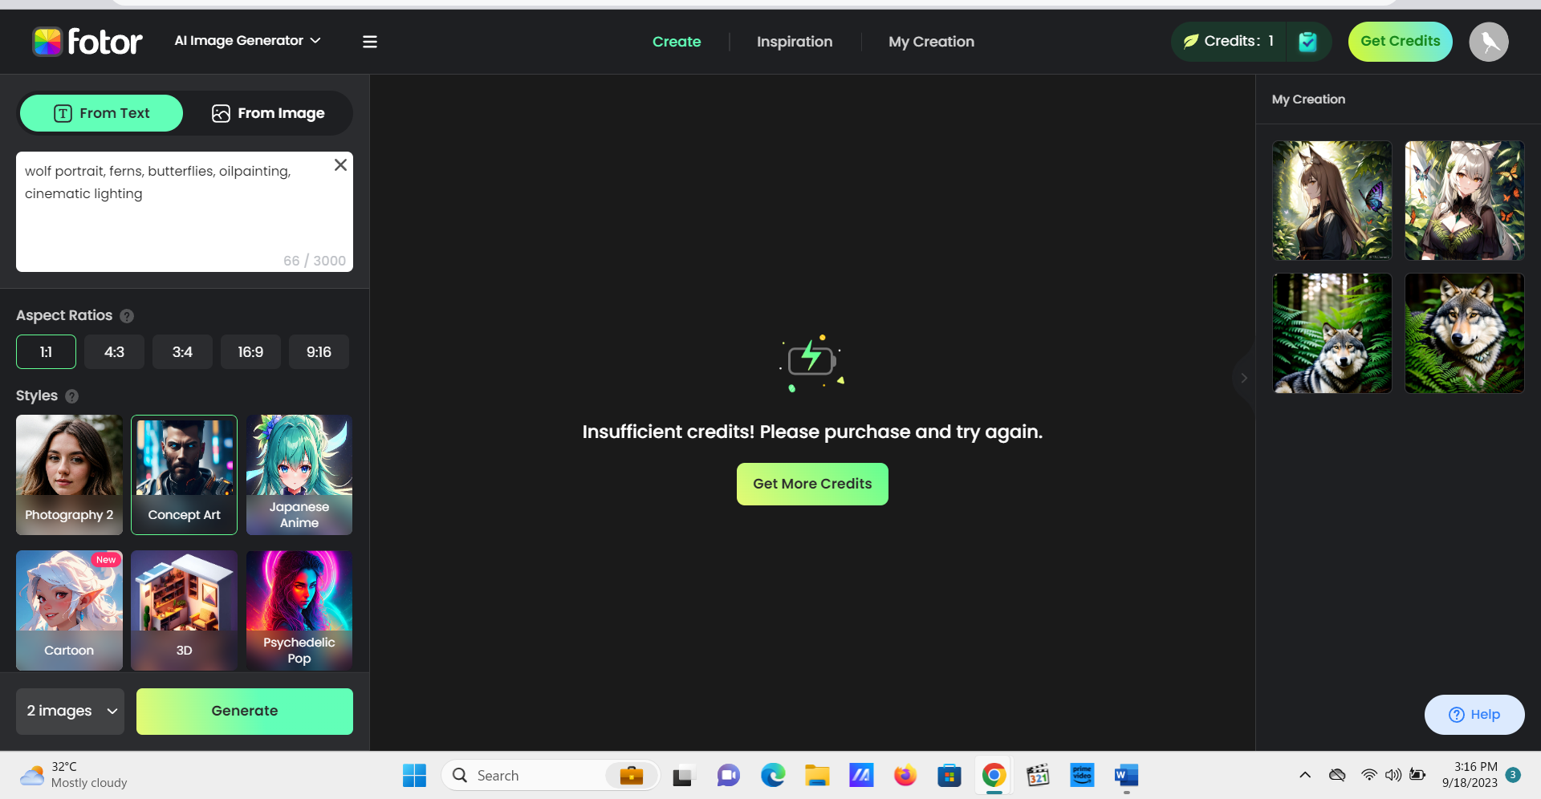  
  
**3. Interior Design:**  
Interior designers can use AI to create visual representations of room designs based on written descriptions or user preferences. Example for this can be InteriorAI.   
  
  
**4. Concept Art and Storyboarding**: Text-to-Image AI is being used in the creative industry to gain appropriate results in generating concept art, storyboarding for films or animations, and visual representations of book descriptions.   
  
Example – Krock.io

**3. Sound to Text AI**

Sound-to-text AI, also known as Automatic Speech Recognition (ASR) technology, is a type of artificial intelligence that converts spoken language into written text. This technology is being used in a wide variety of applications such as transcription services, voice assistants and more.

While helpful, sometimes the accuracy and authenticity of it can be hampered due to several of the external factors such as noise pollutuion, disturbed environment and different way of talking. But continuous development and improvement will definitely fix it.

Here are some of the examples for Sound to Text AI -

1. Google Speech to Text (Ok Google)

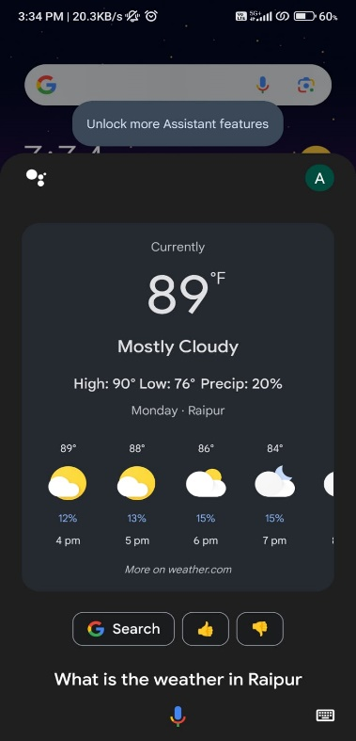  
  
As you can see I asked google a question regarding the weather in Raipur and it listened to my voice and showed me the results. Similar tools like Alexa and Siri also does the same thing. Interactive AI has been with us for well over a decade now and it answers our questions.   
  
2. Amazon Alexa   
  
I asked alexa to find be the best pen from its catalogue and it showed me the list of the pens available.   
  
  
 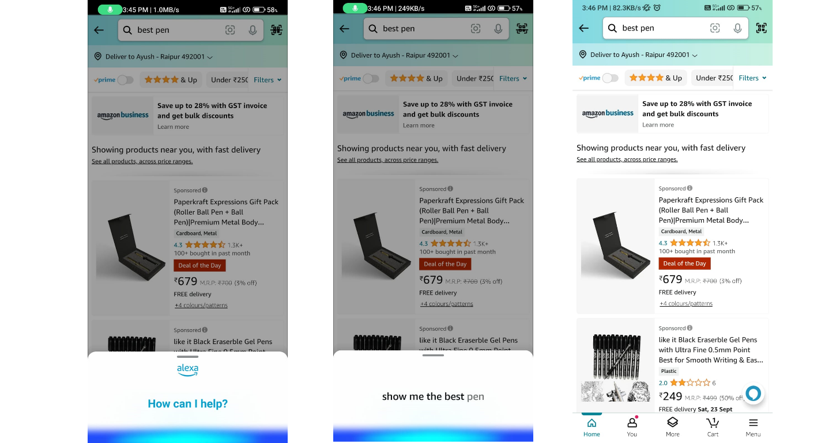  
  
  
   
  
  
  
**Conclusion** – There are several types of Artificial Intelligence with us at the moment which are serving different purposes and commands for us. While there will always be a room for improvement for the technology, one can surely rely on these AI tools to get their job done.

Made by – Ayush Gattani